Lab Report on the Charge of an Electron

Student’s Name
Submission Date

Aims and Objectives
This experiment was aimed at measuring the charge of an electron by the use of the electroplating method. The main objective was to obtain an experimental value of a charge of an electron and compare it with the accepted (theoretical) value. Also, the experiment was meant to boost understanding on how to use the electroplating method in measuring electron charge.

Theory
Ordinary atoms of an element are generally neutral. The neutrality is defined by atom’s equity in the number of positive and negative charges. Through the presence of elementary particles, referred to as protons and electrons, the atom carries a positive charge or a negative charge using these particles, respectively. Thus, when an atom has equal number of protons and electrons, it is termed to a neutral atom. When an electron is lost, the atom becomes a positive ion thus, has a positive charge; and vice versa.
When two electrodes are inserted into a CuSO₄ solution, the ions present i.e. Cu²⁺ and the SO₄⁺² ions get attracted to each other. This is basically from the law that unlike charges attract, like charges repel. The copper ions accumulate at the cathode to form an uncharged atom that is deposited as a metallic copper Cu⁰. The following equation shows the changes:
Cu⁺² + 2e⁻ Cu⁰
The power supply is achieved through connecting wires to the cathode, with facilitate a continuous supply of electrons that in turn converts the copper ions to neutral copper atoms. When a single copper atom is removed from the cathode, one atom is deposited to the anode. The number of positive charges that pass to the anode from the cathode through the electrolyte are equal to the number of electrons passing through the wires per unit time. The interaction is represented in figure 1 below.
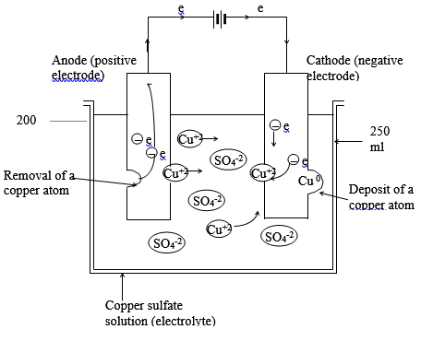
Figure 1: The movement of ions through an electrolyte and movement of electrons through wires

The experiment equipment
The equipment and the materials used during this experiment included: a metric ruler, power towels, a dc ammeter, a dc source, 2 leads with alligator clips and one straight of 24’’ each, a balance beam, a fine sandpaper, glass beakers, copper strips, cupric sulfate, alcohol, water, and a watch.

The Procedure of the Experiment
The current used was 0.02 A per square centimeter of submerged cathode area. The required current was calculated and the figure entered in a table. The power supply was turned on and the switch adjusted until the ammeter read the recorded value of current. Then the power supply was turned off. The electrodes were removed and dipped in the beaker with wash water for a few seconds, then they were dipped in alcohol. After removing them and allowing them to dry, their mass was measured separately in grams and the recordings taken into table 1 of the results. The electrodes were replaced into the solution and the connection confirmed it was right. With the watch ready, the switch was turned on and the starting time recorded. The current was constantly checked to make sure it is constant throughout the experiment. For 40 minutes, the equipment remained undisturbed and the run was terminated, recording the end time run in the table. The cathode was removed carefully, rinsed gently, and dipped in alcohol. When dry, the electrode was measured the new mass and recorded in the table. The same procedure was repeated with the anode. After the experiment, the circuit was disconnected, the electrolyte was poured, and the beakers washed thoroughly.

Results and Calculations
The results of the experiment were tabulated and represented in the following tables: table 1 and table 2;
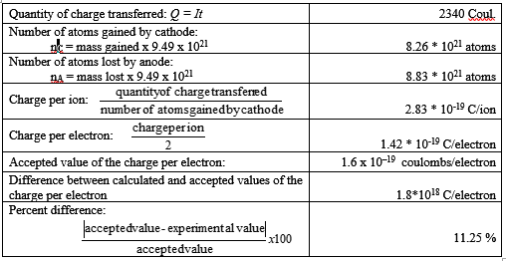
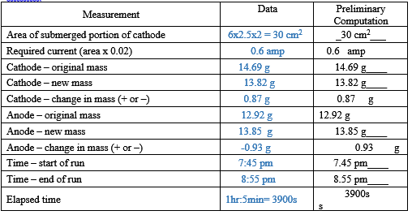
Table 2: The calculations of the charge per electron and the deviation from the accepted value
Table 2: The experimental results and parameters

Questions
- The difference realized on the experimental value from the accepted value is mainly due to errors. The most effective error is during the measurement of change of mass of both the cathode and the anode, the timing errors, and the physical disturbances that are uncontrollable during the experiment.
- The anode mass changed by -0.93 g while that of the cathode changed by 0.87 g. Typically, we expected the deposited copper atoms to the cathode to equate to the material removal from the anode. However, the difference (0.6g) is possibly due to the fact that some ions did not reach to the cathode and mixed up in the electrolyte.
- The copper ions are positively charged and thus, they are attracted to the cathode, which has a negative charge through the electrolyte medium.
- When two copper ions are deposited on the cathode, two electrons are moved through the wires to the anode.
- Rinsing of the electrodes remove water molecules that are attached to it and that can significantly affect the mass measured.
- A. The anode is the one connected last to control the material removal when connecting the circuit.
b. The anode is disconnected first to prevent more movement of the ions through the electrolyte even when the circuit is closed.
7. Current in the electrolyte flows through the ions present whereas the current in the copper wires flows through the movement of electrons.

